**The SipSproutThrive**

**3-Day Detox Guide**

**Because your liver and kidneys deserve a vacation**

**from your poor life choices.**

**Table of Contents**

**1.The Body’s Natural Detox Pathways**

**(Spoiler: Your Liver & Kidneys Are Doing the Heavy Lifting)**

**2. Top 5 Science-Backed Supplements (That Aren’t Snake Oil)**

**3. Red Flags to Avoid (Because "Instant Detox" (Is a Lie)**

**4. Comparative Tables: Brand Showdown (Who’s Actually Worth Your Money?)**

**5. Foods to Eat (And No, Wine Doesn’t Count as a Fruit)**

**6. What to Expect (Hint: You Might Feel Worse Before You Feel Better)**

**7. Pro Tips (Water &amp; Sleep Aren’t Optional, Karen)**

**8. Glossary of Terms (Because "Chlorella" Sounds Like a Sci-Fi Villain)**

**9. Smoothie Recipes (Because Chewing Is Overrated)**

**1. The Body’s Natural Detox Pathways**

Let’s get one thing straight—your body is already detoxing 24/7. Your liver and kidneys aren’t lazy freeloaders; they’re biochemical powerhouses filtering toxins like unpaid interns.

- Liver: Processes toxins into less harmful substances (bile, urine).

- Kidneys: Filter blood, excreting waste via urine.

- Lymphatic System: Drains cellular garbage (if you move your body occasionally).

- Skin & Lungs: Sweat and exhale toxins (yes, your hangover breath counts).

|  |  |  |  |
| --- | --- | --- | --- |
| **Supplement** | **Why It Works** | **Dosage** | **Caveats** |
| **Milk Thistle** | **Boosts liver enzymes (silymarin is the MVP).** | **150–300 mg/day** | **May cause mild diarrhea.** |
| **NAC (N-Acetyl Cysteine)** | **Raises glutathione (liver’s favorite antioxidant)** | **600–1200 mg/day** | **Smells like rotten eggs.** |
| **Chlorella** | **Binds heavy metals (like a detox vacuum).** | **2–3 g/day** | **Start slow—can trigger nausea.** |
| **Dandelion Root** | **Diuretic (kidneys love it).** | **500 mg 2x/day** | **Don’t harvest from your lawn (pesticides).** |
| **Psyllium Husk** | **Sweeps intestines (fiber is your friend).** | **5 g with water** | **Drink *a lot* or risk constipation.** |

Why This Matters: If these systems are sluggish (thanks, fast food and vodka & sodas), toxins build up. A short detox supports them—it doesn’t replace them.

**2. Top 5 Science-Backed Supplements**

**(AKA: The Only Ones That Aren’t Placebos in Fancy Packaging)**

**3. Red Flags to Avoid**

- Instant Detox" Claims: If it promises results in 12 hours, it’s either laxatives or lies.

- Proprietary Blends: Code for "we hid the cheap filler ingredients."

- No Third-Party Testing: Congrats, you’re swallowing sawdust.

**4. Comparative Tables**

**(Because Blind Brand Loyalty Is for Suckers)**

|  |  |  |  |
| --- | --- | --- | --- |
| **Brand** | **Price** | **Third-Party Tested?** | **Verdict** |
| **Pure Encapsulations** | **$$$$** | **Yes** | **Overpriced but reliable.** |
| **NOW Foods** | **$$** | **Yes** | **Budget-friendly hero.** |
| **Random Amazon Brand** | **$** | **No** | **Enjoy your mystery powder.** |

**5. Foods to Eat**

**Do:**

- Cruciferous veggies (broccoli, kale—sulforaphane boosts detox enzymes).

- Beets (betaine supports liver bile flow).

- Garlic (allicin kicks toxins to the curb).

- Lemon water (hydrates + vitamin C for glutathione production).

**Avoid:**

- Alcohol (obviously).

- Processed sugar (feeds gut bacteria like a frat party).

**-** Dairy/gluten (if you’re sensitive, they’ll bloat you like a parade float).

**6. What to Expect**

- Day 1: Energy crash (goodbye, caffeine dependency).

- Day 2: Headaches, irritability (toxins exiting stage left).

- Day 3: Clarity, lighter digestion (congrats).

Digestive Issues? Bloating, gas, or loose stools mean it’s working (or you overdid psyllium).

**7. Pro Tips**

- Water: 2–3L/day (or your kidneys will revolt).

- Sleep: 7–9 hours (melatonin helps detox the brain).

- Exercise: Sweat = free toxin exit route.

8. **Glossary of Terms**

- Glutathione: Liver’s master antioxidant (NAC boosts it).

- Chelation: Fancy word for "binds metals" (chlorella’s superpower).

- Bile: Liver’s waste disposal fluid (eat bitter greens to stimulate it).

**9. Smoothie Recipes**

**"Liver’s Little Helper"**

**- 1 cup kale**

**- ½ beet (cooked)**

**- 1 tbsp dandelion root powder**

**- 1 tsp ginger (for nausea)**

**- 1 cup almond milk**

**- Blend and suffer through the earthy taste.**

**Chlorella Shock Therapy**

**- 1 tsp chlorella powder**

**- 1 banana (to mask the swamp flavor)**

**- 1 tbsp almond butter**

**- 1 cup coconut water**

**- Blend and pretend it’s a margarita.**

**Final Note: This isn’t a magic fix—it’s a reset. If you go back to eating like a raccoon in a dumpster, you’ll undo it in 48 hours. You’ve been warned.**

**Your Body’s Built-In Detox Team**

Did you know your body has its own sophisticated detoxification system working around the clock? You don’t need extreme cleanses or magic potions—your liver, kidneys, digestive system, skin, and lungs are already hard at work keeping you clean from the inside out. Let’s meet your natural detox dream team!

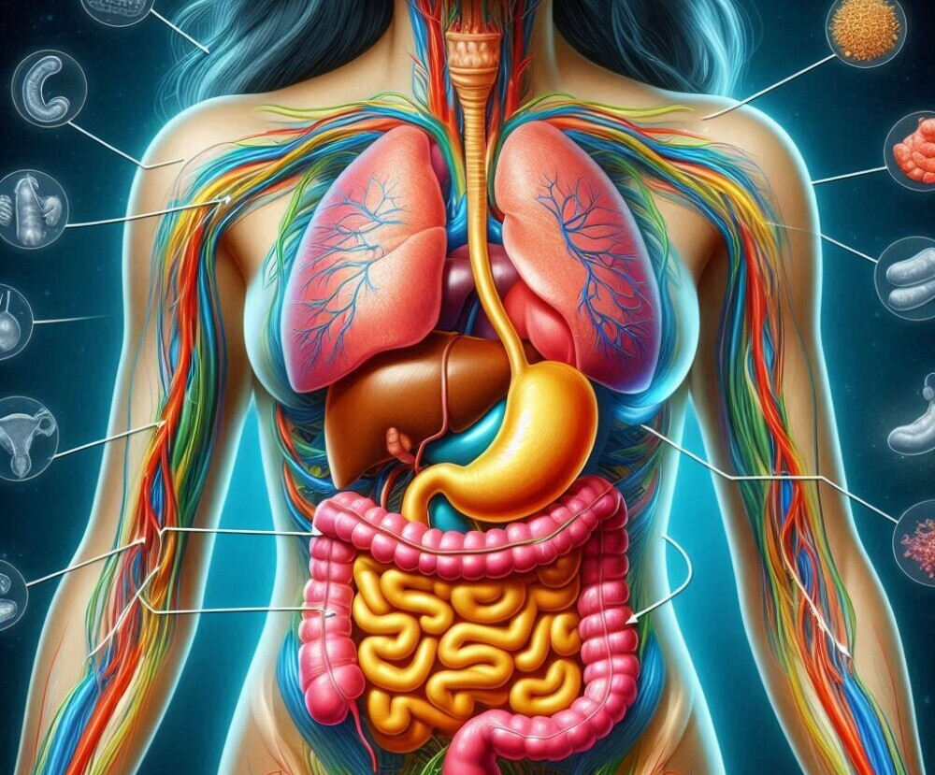

**1. The Liver: Your Master Filter**

Your liver is like a highly efficient processing plant—sorting nutrients, neutralizing toxins, and preparing waste for elimination.

How it helps you:

• Processes everything you eat, drink, and breathe

• Breaks down alcohol, medications, and environmental toxins

• Produces bile to help digest fats and carry away waste

Fun fact: Your liver performs over 500 vital function

**2.The Kidneys: Nature’s Water Filters**

These two bean-shaped organs work nonstop to clean your blood.

**Their superpowers:**

• Filter about 200 quarts of blood daily

• Balance fluids and electrolytes

• Remove waste through urine

**Tip**: Staying hydrated helps them work efficiently!

**3. The Digestive System: Your Daily Cleanup Crew**

From mouth to colon, your digestive tract eliminates waste every single day.

Why it matters:

• Fiber moves toxins out through regular bowel movements

• Healthy gut bacteria help process and neutralize toxins

• 70% of your immune system lives here!

Did you know? Constipation means toxins stick around longer than they should.

**4. The Skin: Your Protective Outer Layer**

Your body’s largest organ eliminates toxins through sweat.

Sweet benefits of sweating:

• Releases heavy metals and other impurities

• Helps regulate body temperature

• Supports immune function

Pro tip: Dry brushing before showers can boost skin detox!

**5. The Lungs: Your Air Purifiers**

With every breath, your lungs oxygenate your blood and release waste gases.

Breathe easy knowing:

• Deep breathing stimulates lymphatic drainage

• They filter airborne pollutants

• Proper oxygenation supports all detox processes

Try this: Practice deep belly breathing for 5 minutes daily.

**How These Systems Work Together**

Imagine your body as a busy city:

• The liver is the recycling center

• Kidneys are the water treatment plant

• Digestive system is the waste management service

• Skin and lungs are the ventilation systems

When all systems work smoothly, toxins don’t stand a chance!

**Why Support Matters**

While your body is designed to detox naturally, modern life creates extra challenges:

• More environmental toxins than ever before

• Processed foods lacking nutrients

• Chronic stress that slows detox pathways

This is why periodic gentle cleanses with nourishing foods can be so helpful—they give your hardworking systems some extra support!

Remember: True detox isn’t about punishing restrictions—it’s about nourishing these incredible systems your body already has. In the next chapter, we’ll explore gentle ways to support each of them!

*P.S. Isn’t it amazing what your body does for you every day without you even thinking about it?*